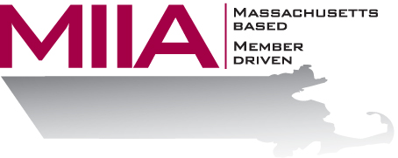

Avoiding Conflict Avoidance
September 22, 2016
2:00-3:00 PM

Research shows that the number one reason problems don’t improve in the workplace is because of avoidance, and nowhere is this truer than when managing conflict. This webinar looks at the skills and strategies we need to effectively resolve disagreements in today’s municipal workplace – or, how to avoid avoiding.

About the Presenter:
Cally Ritter is an EAP consultant with AllOne Health EAP, and a Licensed Independent Clinical Social Worker. She has a B.A. from Bucknell University, a master of social work from the University of Pittsburgh, and twenty years of clinical experience in a variety of settings, including inpatient and outpatient services in Philadelphia, Pittsburgh and Boston. Cally has been an EAP trainer for more than ten years, and has presented on a variety of personal and professional development topics. Her areas of interest include the multigenerational workplace, resiliency and employee motivation. She infuses her seminars with energy, examples, exercises, and content excellence.

To register:
Please go to the following link and complete the required information:
https://attendee.gotowebinar.com/register/55193661740024065
After registering, you will receive an email containing webinar access details. See you there!

