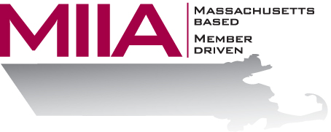
MIIA Professional Development Training

Substance Abuse in the Workplace
November 2, 2017
2:00-3:00 PM

Addiction among employees is one of the most difficult issues that employers encounter. More money is lost in American industry from untreated addiction than from any other single source. This webinar will provide participants with knowledge about the disease of addiction, signs and symptoms of substance abuse in the workplace, and information about treatment options.

About the Presenters:
Dr. Madelynn Azar-Cavanagh, MD, MPH, CPE, FACOEM has recently joined AllOne Health as the Corporate Medical Director. Dr. Azar-Cavanagh is an accomplished physician with more than 25 years’ experience in Occupational Medicine. She is Board Certified and a Fellow of the American Board of Occupational and Environmental medicine. Before joining AllOne Health, she was the Medical Director of Employee Health, Safety and Wellness at the Mount Sinai Health System in New York, where she oversaw the health and wellbeing of their 36,000 staff members at 7 hospital locations. Dr. Azar-Cavanagh was born in Philadelphia, PA and received her medical degree from Boston University School of Medicine. Her MPH was from the Medical College of Wisconsin and she completed her residency in Occupation Medicine at the University of Pennsylvania. She recently obtained a degree as a Certified Physician Executive in Medical Management.
Kimberly Jones, LCSW is a military veteran who recently joined AllOne Health. As a Licensed Certified Social Worker, her experience includes providing therapeutic support to couples, families, and children, serving adults with co-occurring disorders in addiction treatment, and crisis management. Her areas of expertise include, but are not limited to: adjustment disorders, anxiety disorders, ADHD/ADD, behavior modification, and cognitive behavioral therapy. Kimberly earned a master’s degree in Social Work from New York University, NY. She enjoys traveling and meeting new people.

To register:
Please go to the following link and complete the required information:
https://attendee.gotowebinar.com/register/7218749418462468353
After registering, you will receive an email containing webinar access details. See you there!

