**MIIA RISK MANAGEMENT ADVISORY**

**STATIONARY COMPACTORS and SITE SAFETY AT TRANSFER STATIONS**

# Hazards - Severe fall, crushing, and caught between hazards are posed when employees or contractors:

* 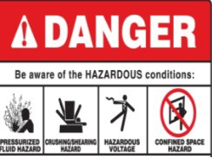Feed materials into compactor.
* Attempt to clear jams and retrieve items that fell in.
* Clean, repair, or maintain compactor.
* Attempt to use the compactor opening with unprotected edges.

**Fatality Assessment and Control Evaluation (FACE)** – A NIOSH report of *20 Compactor Related Fatalities* found that victims had either reached or fell into the compression chamber, and were **crushed** in the compacting chamber, or suffered amputation from being **caught between** the ram and the compacting chamber walls.

These fatal incidents illustrate a lack of policy, administrative controls, and work practices to prohibit entering the compactor as the victims had been clearing a jam or were attempting to retrieve material. Other cases illustrate a lack of Lock-Out/Tag-Out and Permit Required Confined Space Programs as the machine cycled automatically when victim entered compacting chamber, and when coworkers activated compactor without knowing a worker was inside.

# Risk Reduction Strategy Recommendations:

* Prohibit bypassing the interlock on compactors and operating them with the doors open.
* Prohibit entry into the compactor for any reason, unless trained and authorized to do so:
  + Post a *Permit Required Confined Space* sign near the compactor(s).
  + Require contractors to have a *Lock-Out/Tag-Out (LO/TO) Program* or implement a *LO/TO Program* for all work requiring deenergizing the compactor.
  + Provide tools, protocols, and training for retrieving items and clearing jams without entering the compactor.
  + Provide guardrails for each type of unprotected openings:

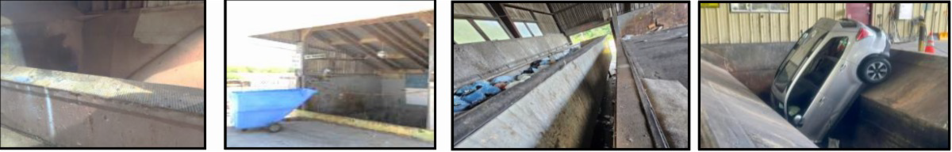Per OSHA specifications for access to the compactor by pedestrians.

Per OSHA specifications to resist a vehicle for breaching compactor openings by vehicles.

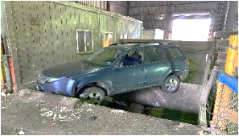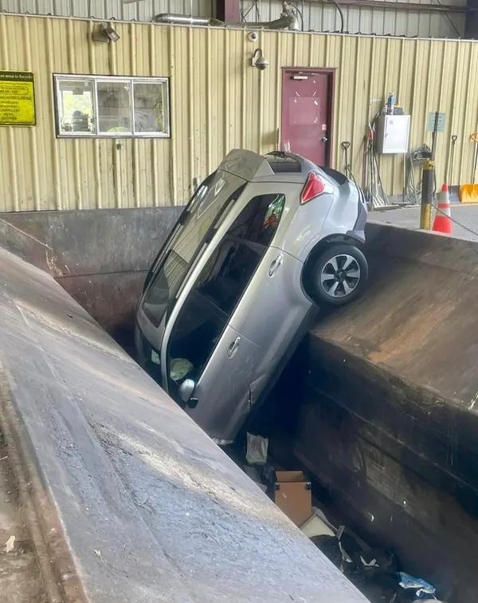

**Site Safety**

* Hazards - people have been hit due to inadequate visibility and lack of traffic and site controls on a site with moving vehicles and pedestrian and employee foot traffic.
* Risk Reduction - provide speed limits, signage, traffic control devices ( e.g. cones, barriers), pavement markings, etc. for traffic control, and adequate lighting and high visibility vests for employee visibility.

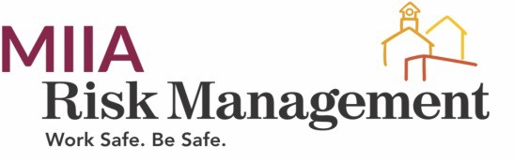**© MIIA All rights reserved. Created April 8, 2024, Revised December, 2024**

Massachusetts Interlocal Insurance Association | Serving Massachusetts’ communities since 1982 Boston, MA | 617-326-7272 | 800-882-1498 | [www.emaiia.org](https://www.emaiia.org/)